

CLOUD COMPUTING LAB
BSE ( V-B )

Submitted By:
Musfira Farooq
Roll No:
2023-BSE-045
Submitted To:
Sir Muhammad Shoaib

LAB 15(PROJECT)
Terraform + Ansible Roles: Nginx Frontend with 3 Backend HTTPD Servers (HA + Auto-Config)

TABLE OF CONTENTS
Introduction 3
Architecture Overview 3
Infrastructure Design (Terraform) 3
Configuration Management (Ansible) 4
Backend Role Behavior 4
Frontend Role Behavior 4
Nginx Load Balancer Behavior 4
Normal Operation 4
Automation with Terraform and Ansible 5
Practical outputs 5
Project Structure 6
Verification Results 15
Backend URLs 15
Frontend URL 16
Conclusion 17
Repository link 17

Introduction
This lab project demonstrates the deployment of a high-availability web architecture on AWS using Terraform for infrastructure provisioning and Ansible roles for configuration management.
The system consists of:
- 1 Frontend EC2 instance running Nginx
- 3 Backend EC2 instances running Apache HTTPD
- 2 active backends + 1 backup backend

Architecture Overview
Component | Description
VPC | Custom VPC with public subnet
Frontend EC2 | Nginx reverse proxy and load balancer
Backend EC2s | Apache HTTPD web servers
Security Group | SSH (22) and HTTP (80) access
Automation | Terraform + Ansible integration

Infrastructure Design (Terraform)
Key Terraform Features:
- Custom VPC, Subnet, Internet Gateway
- Public subnet with Internet access
- Security group allowing:
- SSH from developer IP
- HTTP from anywhere
EC2 instances:
- 1 frontend
- 3 backends
- Use of variables, locals, and outputs

Configuration Management (Ansible)
Role | Purpose
backend | Install Apache HTTPD and deploy unique backend page
frontend | Install and configure Nginx load balancer
common (optional) | Base configuration (if used)

Backend Role Behavior
- Installs Apache HTTPD
- Enables and starts HTTPD service
Deploys a dynamic HTML page showing:
- Backend identity
- Private IP address
- Each backend displays distinct content.

Frontend Role Behavior
- Installs Nginx
- Configures Nginx as a reverse proxy
Uses an upstream configuration with:
- 2 primary backend servers
- 1 backup backend server
- Automatically restarts Nginx when configuration changes

Nginx Load Balancer Behavior

Normal Operation
Requests to frontend IP are distributed between:
- Backend 1
- Backend 2
When Backend 1 and Backend 2 are stopped:
- Requests are served by Backend 3 (backup)
- This confirms high availability and fault tolerance.

Automation with Terraform and Ansible
- Terraform provisions all EC2 instances
- Terraform triggers Ansible automatically using null_resource
- No manual ansible-playbook command is required
- Re-running terraform apply is idempotent

Practical outputs
Creating repository:
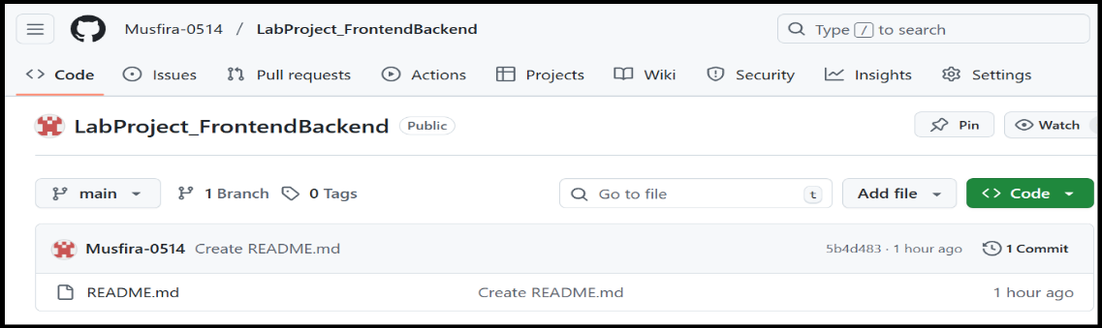
Codespace loaded and creating files and folders:
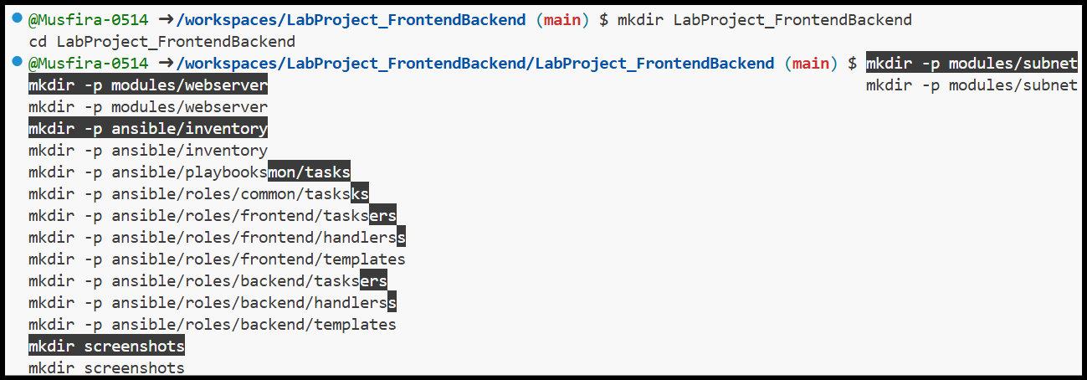
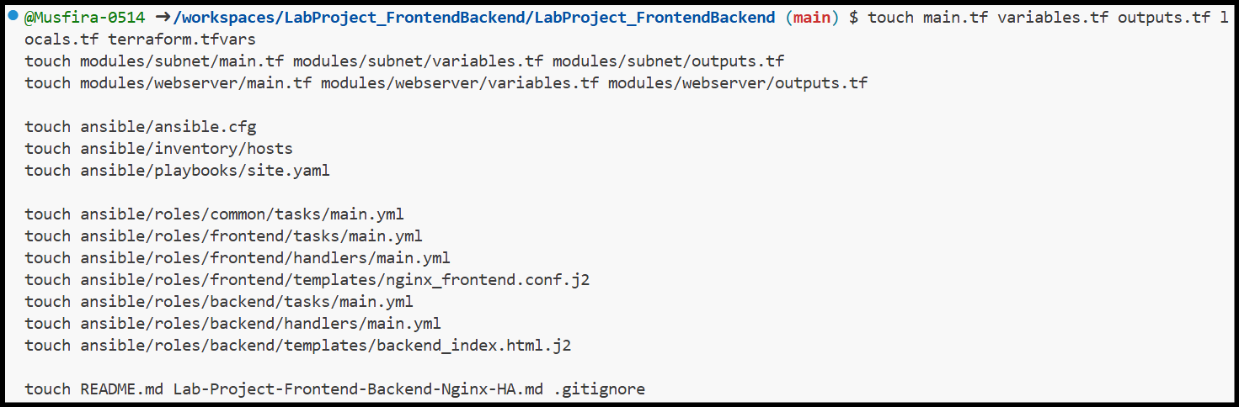

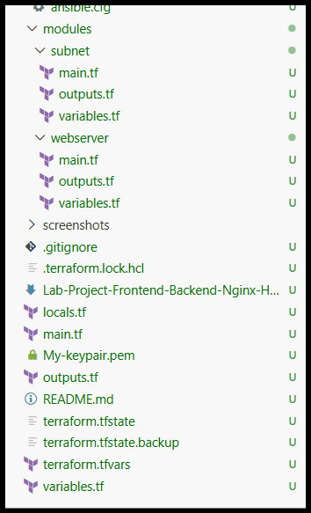
Project Structure
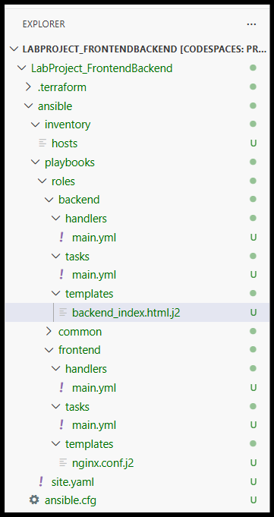
Installing required terraform,aws and ansible:
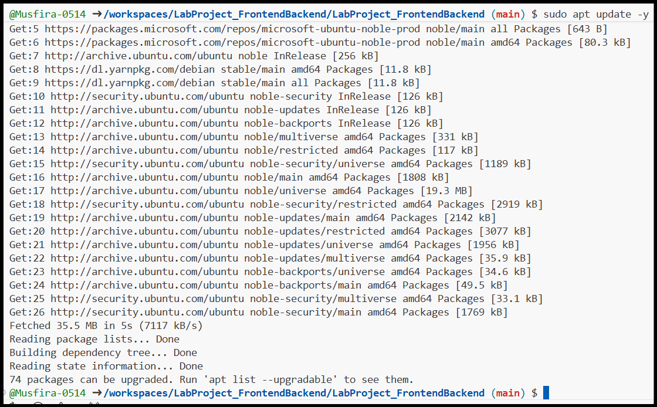
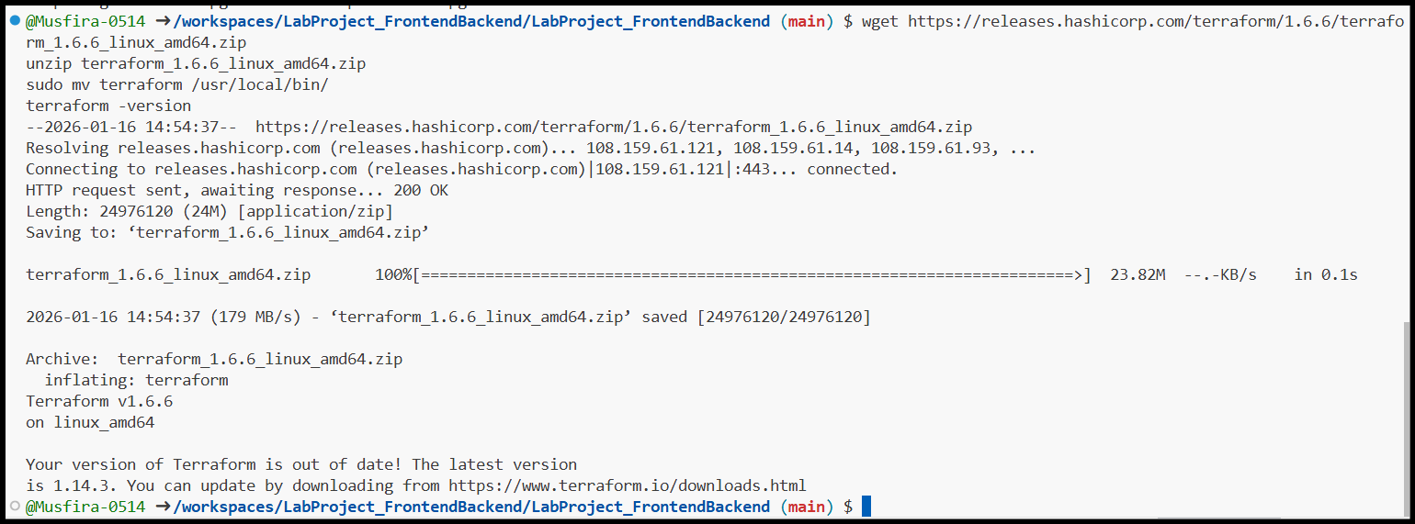
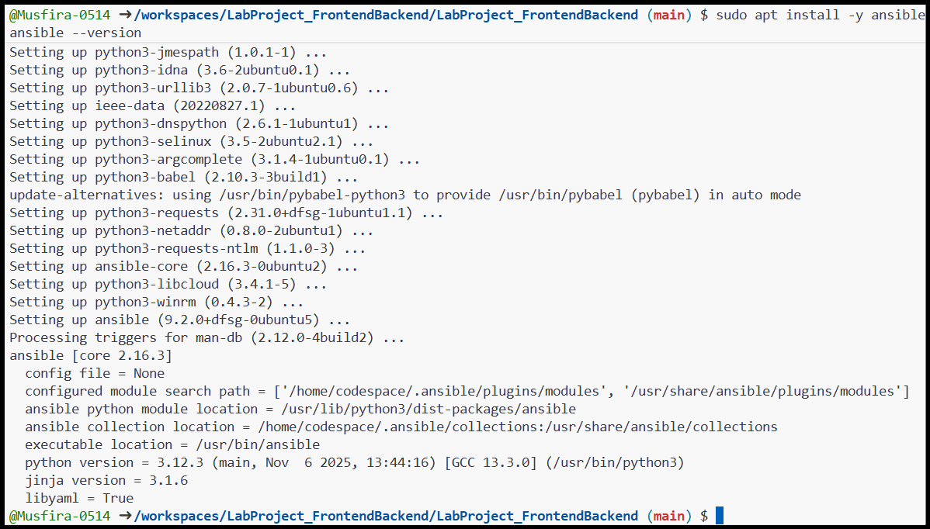
Root main.tf:
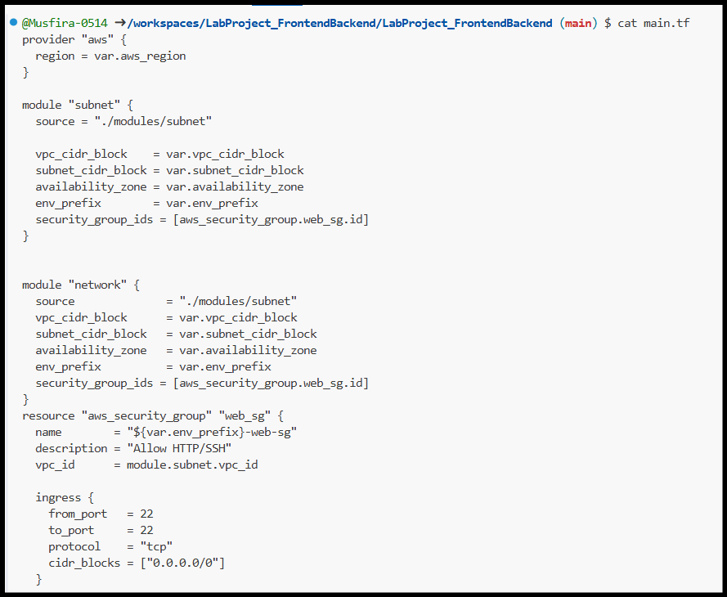
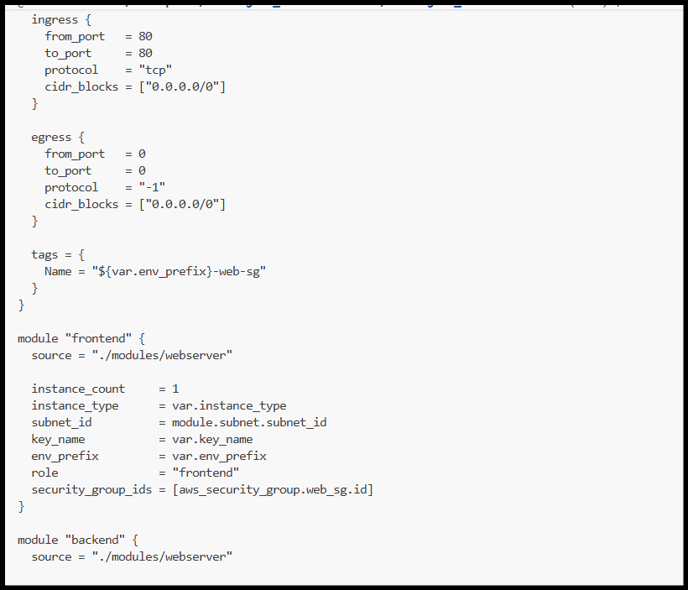
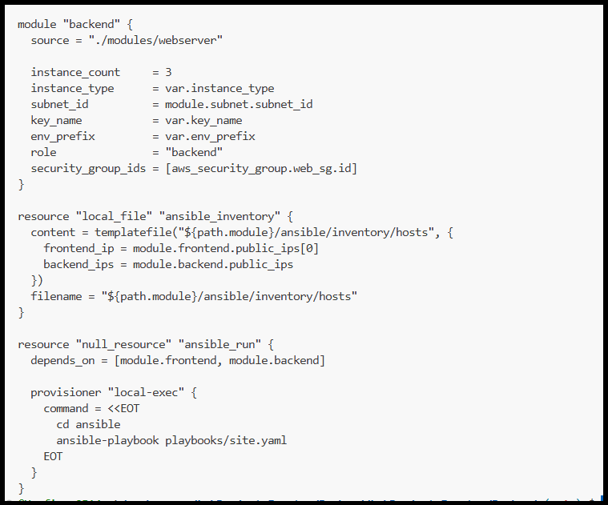
Root variables.tf:
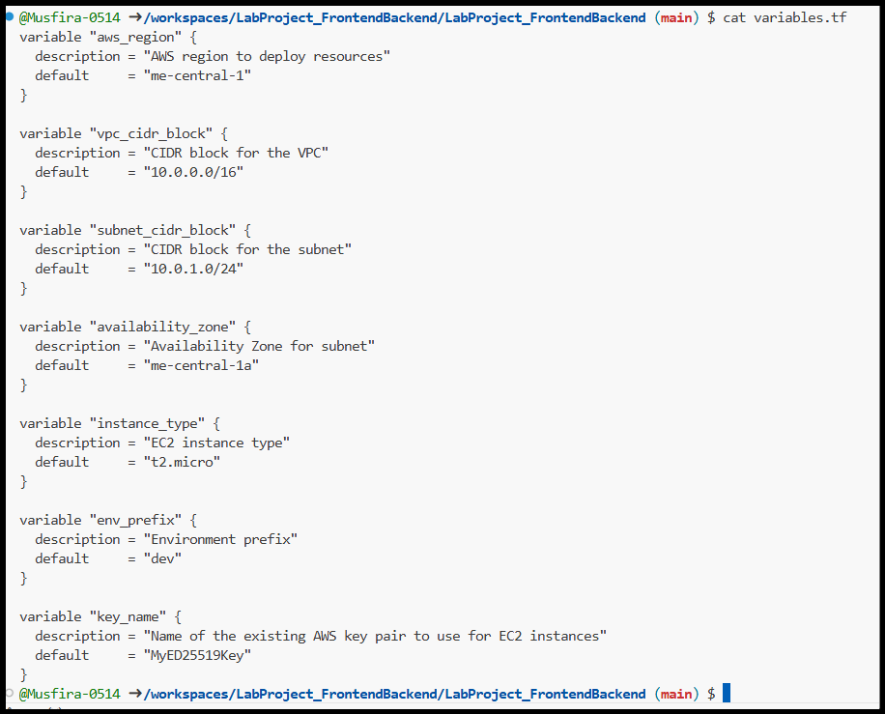
Root outputs.tf:
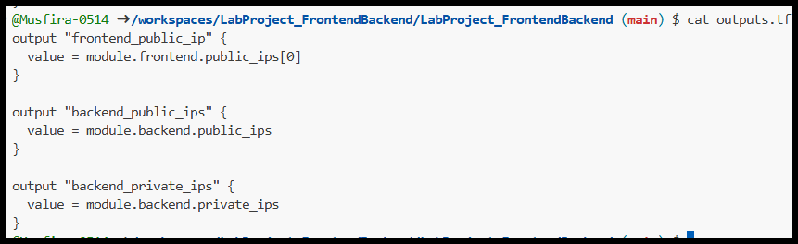
Root locals.tf:
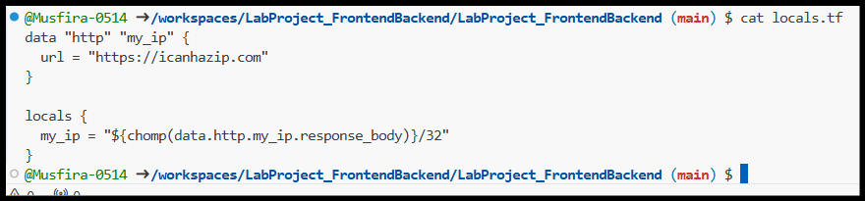
Terraform.tfvars:
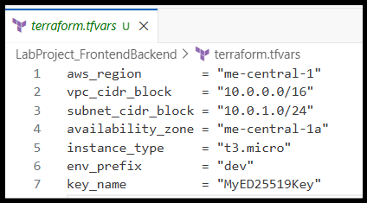
.Gitignore
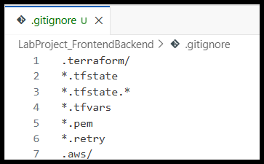
Webserver/main.tf:
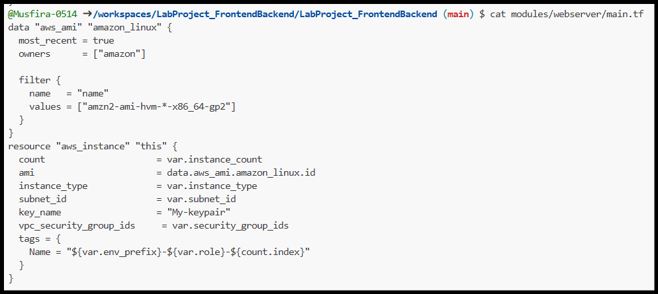
outputs.tf:
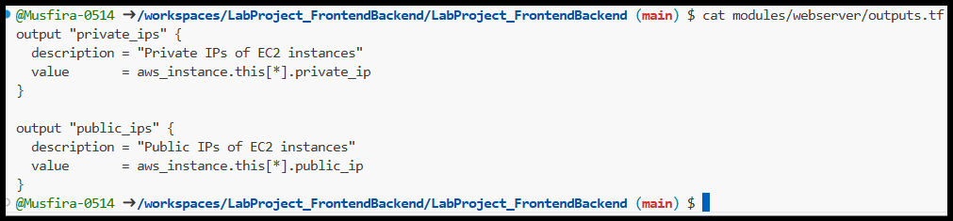
Variables.tf:
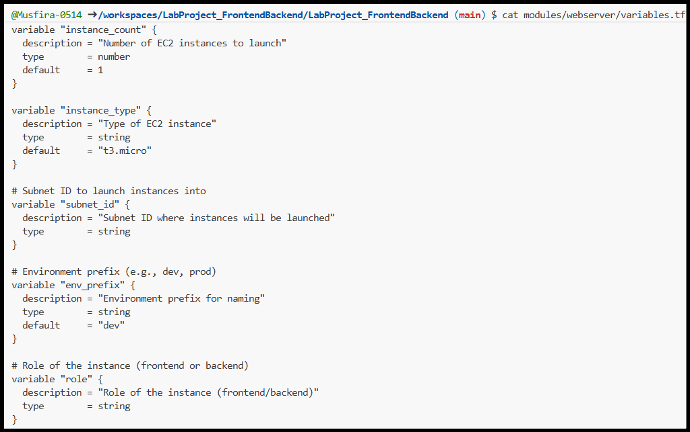
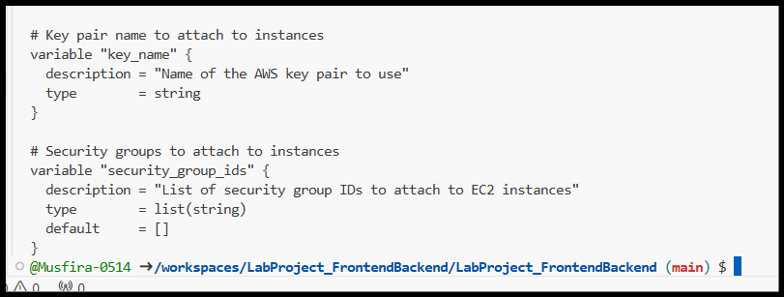
Subnet/main.tf:
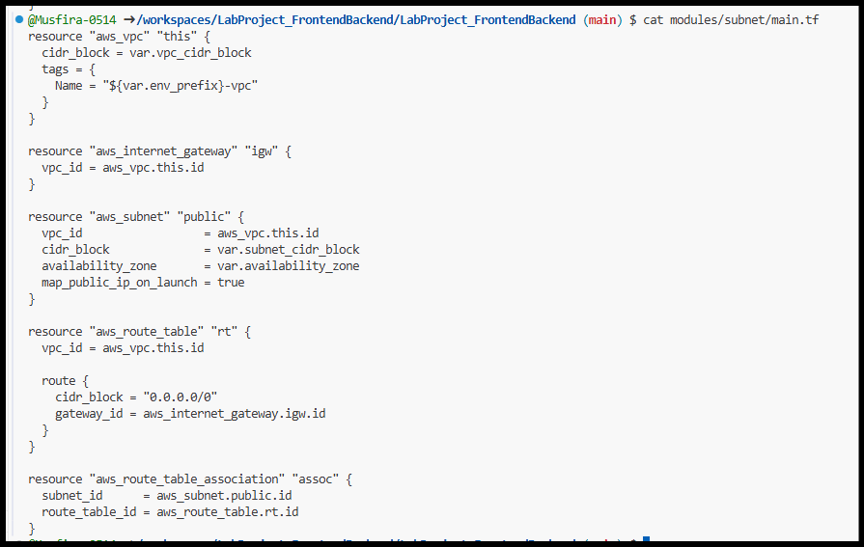
Outputs.tf & Variables.tf:
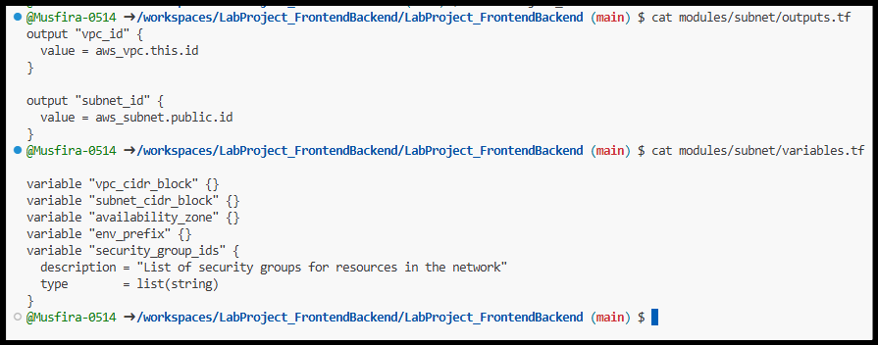
Ansible.config:
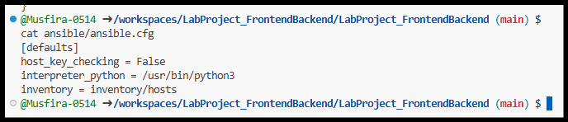
Inventory/hosts:
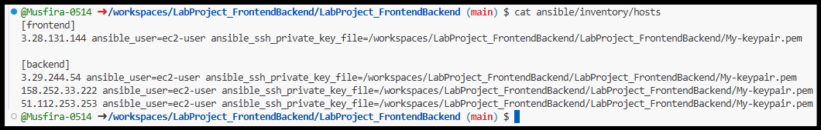
Playbook/site.yml:
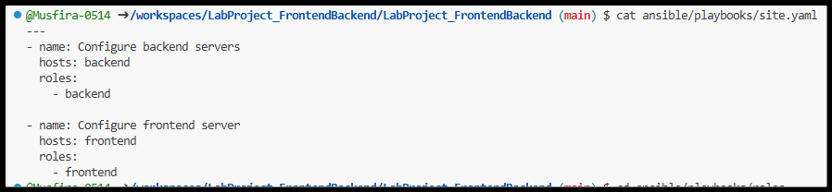
Backend Files:
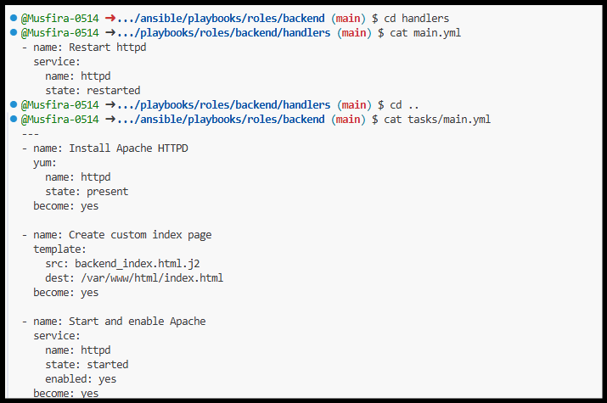
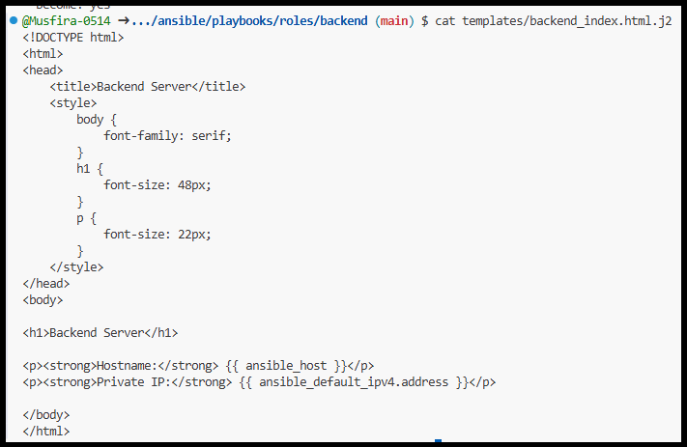
Frontend Files:
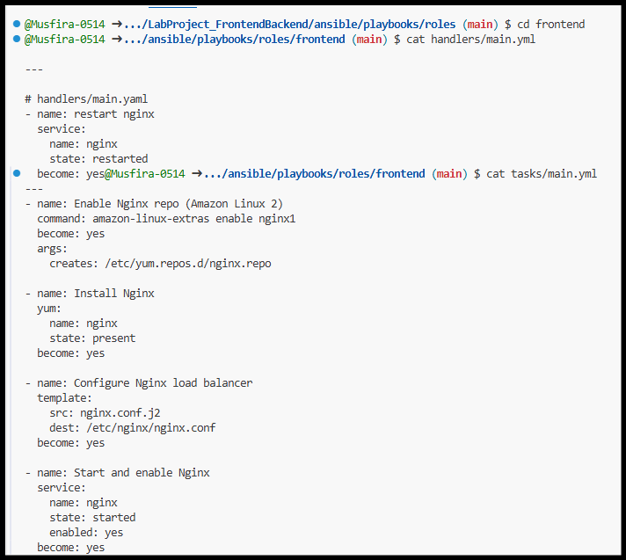
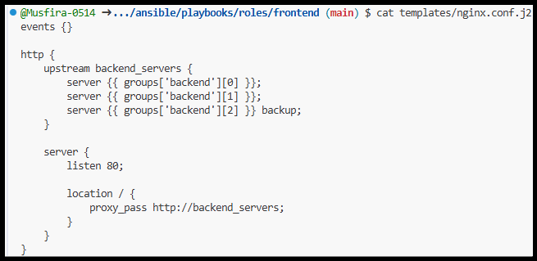
Key generation:
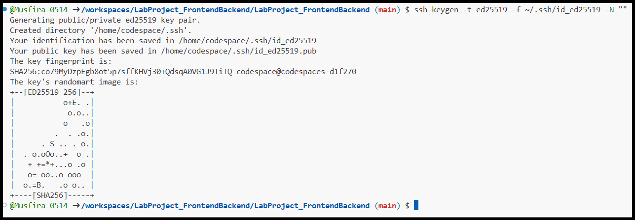
Terraform init & validate:
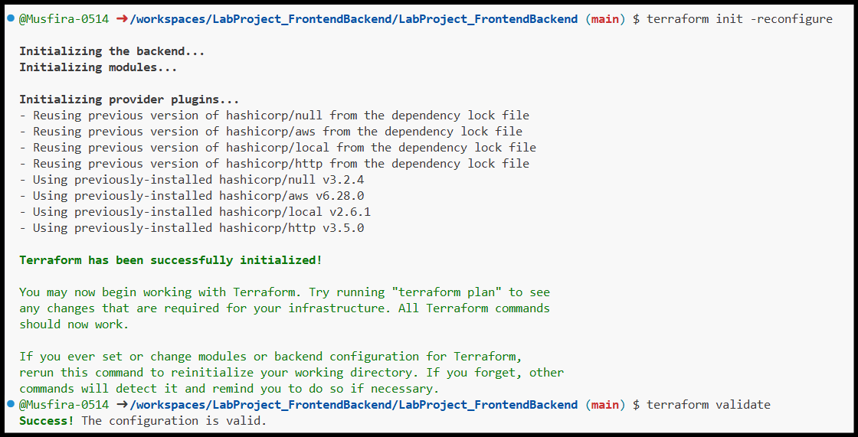
Terraform auto approve:
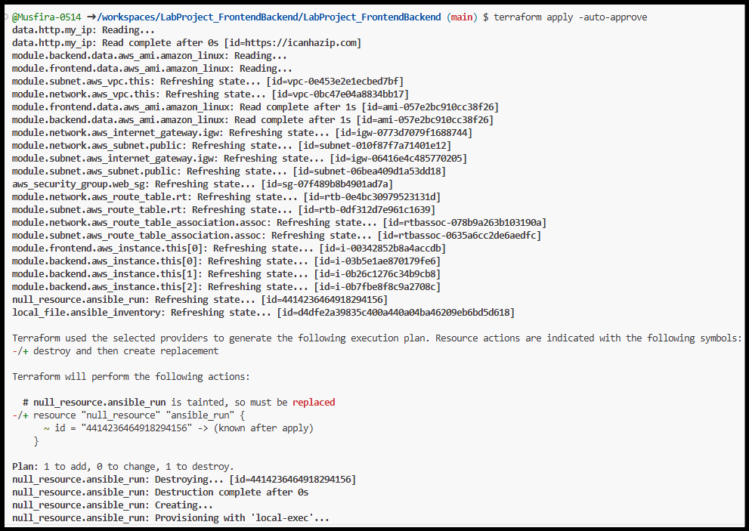

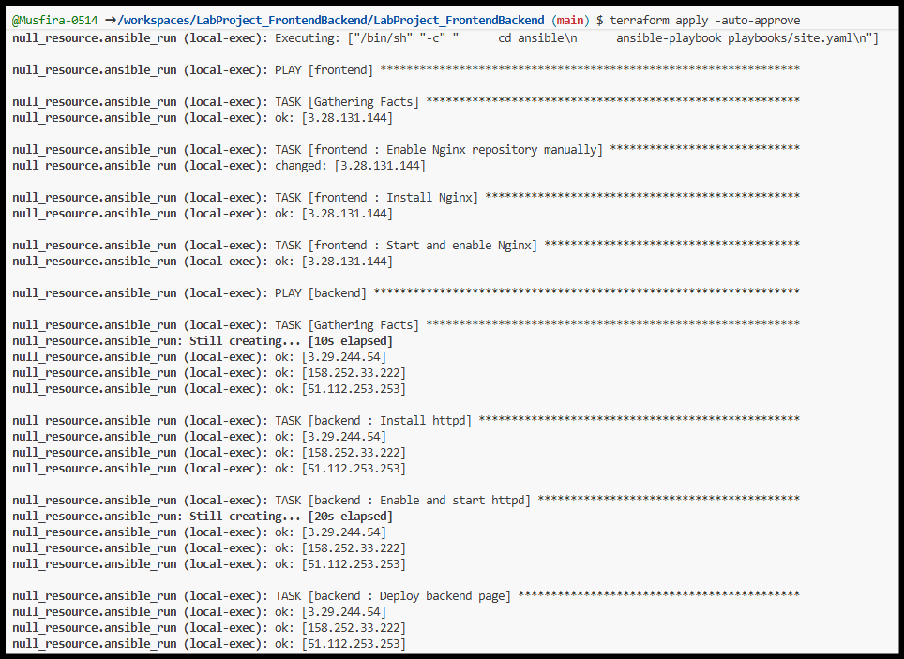
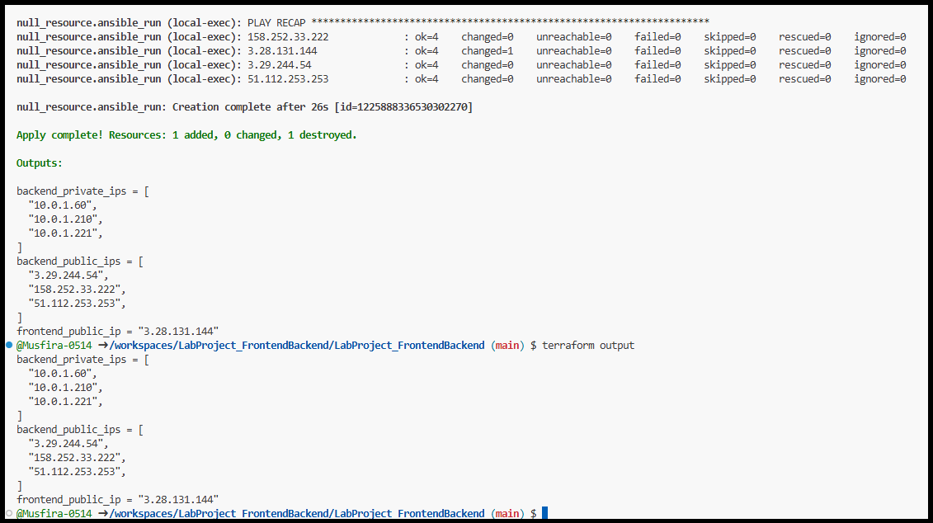
Testing ansible playbooks/roles:
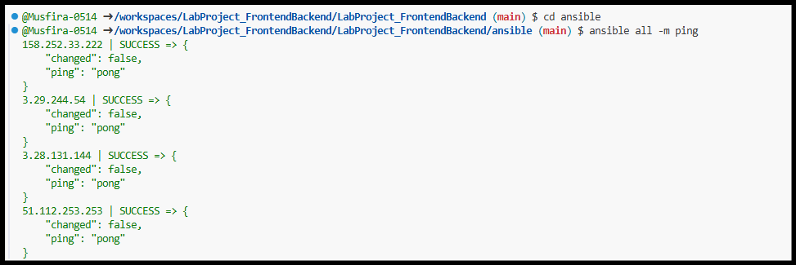

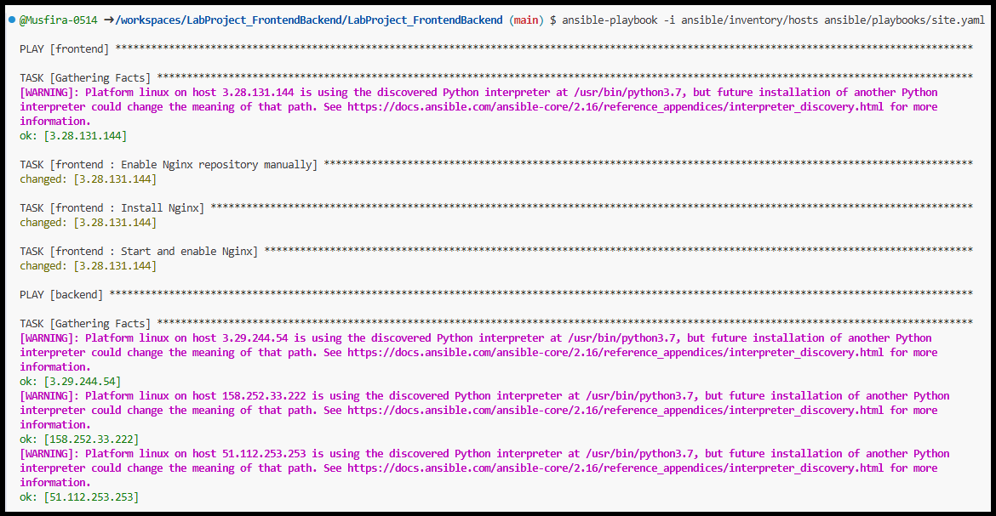
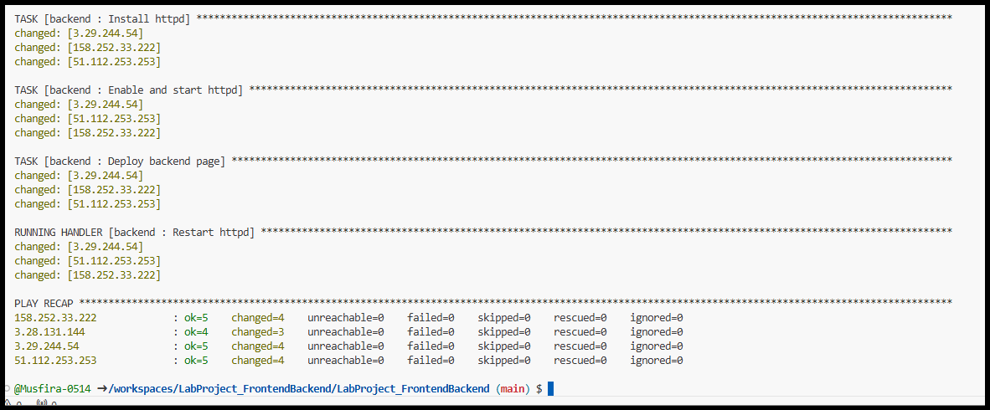

Verification Results

Backend URLs
- http://3.29.244.54
- http://158.252.33.222
- http://51.112.253.253
Each backend displays a unique page.

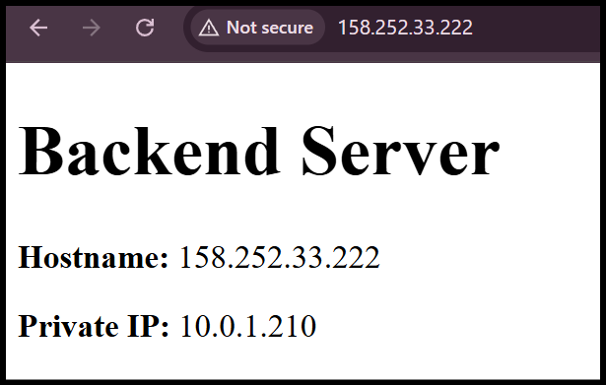
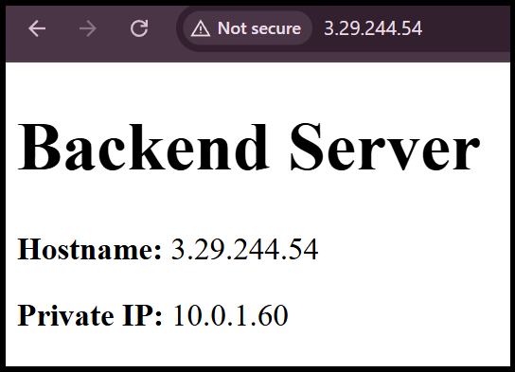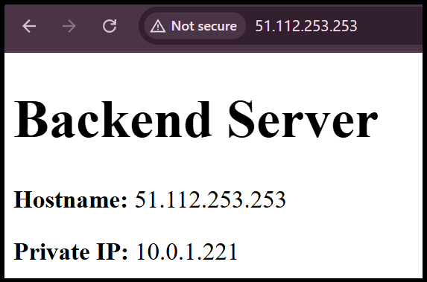

Frontend URL
http://3.28.131.144
Alternates between backend 1 and backend 2
Serves backup backend when primaries are down
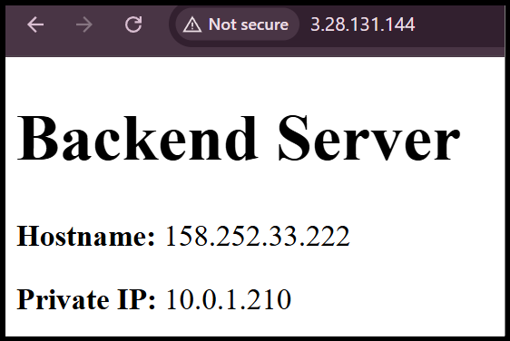
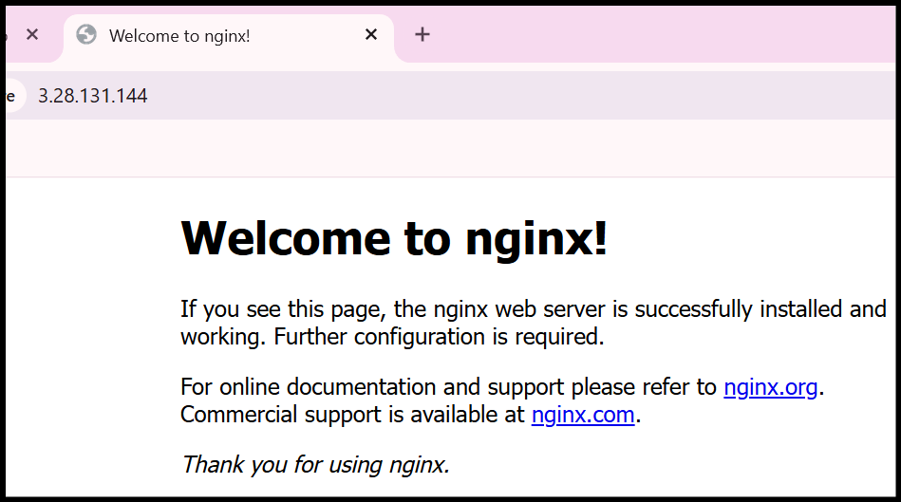
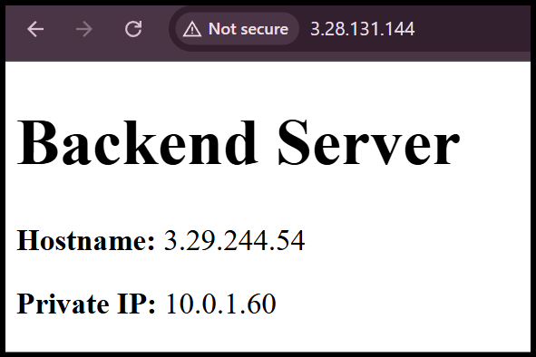

Conclusion
This project successfully demonstrates a fully automated, highly available web architecture using industry-standard tools. The use of Terraform and Ansible roles ensures scalability, maintainability, and repeatability of deployments.

Repository link
https://github.com/Musfira-0514/LabProject_FrontendBackend
https://github.com/codespaces/probable-space-invention-qv9q7jx5rgr249j4

